IMPACTS ON SOILS FROM CUT-TO-LENGTH AND WHOLE TREE HARVESTING

A Thesis

Presented in Partial Fulfillment of the Requirements for the

Degree of Master of Science

with a

Major in Forest Products

in the

College of Natural Resources

University of Idaho

by

Sang-Kyun Han

August 2006

Major Professor: Han-Sup Han, Ph.D.

AUTHORIZATION TO SUBMIT THESIS

This thesis of Sang-Kyun Han, submitted for the degree of Master of Science with a major in Forest Products and titled "Impacts on soils from cut-to-length and whole tree harvesting” has been reviewed in final form. Permission, as indicated by the signatures and dates given below, is now granted to submit final copies to the College of Graduate Studies for approval.

Major Professor _____________________________ Date ______________
Han-Sup Han, Ph.D.

Committee
Members _____________________________ Date ______________
Leonard R. Johnson, Ph.D.

_____________________________ Date ______________
Deborah S. Page-Dumroese, Ph.D.

Department
Administrator Date ______________
Thomas M. Gorman, Ph.D.

Discipline's
College Dean _____________________________ Date ______________
Steven B. Daley Laursen, Ph.D.

Final Approval and Acceptance by the College of Graduate Studies

_____________________________ Date ______________
Margrit von Braun, Ph.D.

ABSTRACT

A field-based study was conducted to compare the degree and extent of impacts on soils from cut-to-length (CTL) and whole tree (WT) harvesting operations. A CTL harvesting system used less area to transport logs to the landings than did the WT harvesting system (20% vs. 25%). At high soil moisture levels (25 - 30%), both CTL and WT harvestings caused a significant increase of soil resistance to penetration (SRP) and bulk density (BD) in the track compared to undisturbed area (p<0.05). Readings of SRP in the track were consistently higher for all soil depths in CTL units than in the WT units while BD changes were greater in the WT units. There was no significant difference in SRP and BD between the undisturbed area and the center of the forwarding trails in the CTL harvest units (p>0.05). However, in the WT harvest units SRP and BD readings from the centerline area were significantly higher than those from the undisturbed area (p<0.05). Slash covered 69% of the forwarding trail area in the CTL harvesting unit; 37% was in heavy slash while 32% of the trail was covered by light slash. Heavy slash was more effective in reducing soil compaction in the CTL units. Prediction models were developed that can be used to estimate percent increases in SRP and BD over undisturbed areas for both CTL and WT harvesting systems.

ACKNOWLEDGEMENTS

I would like to thank my supervisor, Dr. Han-Sup Han for his advice, support and friendship during my degree. I would also like to thank the members of my committee, Dr. Leonard R. Johnson and Dr. Deborah S. Page-Dumroese for their advice and input during this study. I should also like to thank the following: Adebola Adebayo, Fei Fan, and Jarel Bruce for helping to collect field data; Joanne Tirocke of the USDA Forest Service, Rocky Mountain Research Station, Moscow for her advice and data analysis; Dr. Chris Williams for helping with the data analysis; and finally Potlatch Co., Roy Lawson logging, and Bowel logging company for letting me conduct my research while they were working.

Finally, I must thank my parents, brother and sister’s family for their continual support, courage and advice throughout my degree.

TABLE OF CONTENTS

AUTHORIZATION TO SUBMIT THESIS ii
ABSTRACT iii
ACKNOWLEDGEMENTS iv
TABLE OF CONTENTS v
LIST OF TABLES vi
LIST OF FIGURES vii
INTRODUCTION 1
OBJECTIVES 3
STUDY METHODS 4
RESULTS 9
Soil moisture 9
Soil resistance to penetration (SRP) 10
Soil bulk density (BD) 12
Trail area categorized by the number of machine passes 15
Slash in the CTL harvesting unit 16
Prediction models to estimate potential soil impacts 18
DISCUSSION 20
Degree of soil compaction in the trails 20
Soil resistance to penetration (SRP) 20
Soil bulk density (BD) 21
Soil resistance to penetration (SRP) and Soil bulk density (BD) 22
Extent of soil compaction 23
Importance of slash to mitigate compaction 25
Prediction models to estimate potential soil impacts 26
CONCLUSION 30
REFERENCES 31
APPENDIX 34

LIST OF TABLES

Table 1. CTL and WT harvesting system equipment descriptions 5
Table 2. Mean of soil resistance to penetration (SRP) on the reference, trail center,
and track after CTL or WT harvesting 10
Table 3. Mean values for soil resistance to penetration (SRP) collected from the
reference, trail center, and track after harvesting using CTL or WT
systems 11
Table 4. Bulk density (BD) in the reference, trail center, and track at three soil
depths after harvesting with CTL or WT systems 12
Table 5. Mean values for soil bulk density (BD) collected from the reference, trail
center, and track after harvesting with CTL or WT systems 13
Table 6. Average trail width, track width, and area of trails in CTL and WT
harvest units 15
Table 7. Prediction model to estimate percent increase of soil resistance to
penetration when soil moisture content was 25 - 30% 18
Table 8. Prediction model to estimate % increase of soil bulk density (BD) when
soil moisture was 25 - 30% 19

LIST OF FIGURES

Figure 1. Location of the study site in northern Idaho 4
Figure 2. Map of the study site and the trails used by CTL and WT systems 6
Figure 3. Diagram showing transect and sampling areas along the trail 7
Figure 4. Average soil moisture content at three soil depths before and after
harvest using CTL or WT systems as well as during the collection of
soil resistance to penetration (SRP) data 9
Figure 5. Percent increase of soil resistance to penetration (SRP) after harvesting
using CTL or WT systems 11
Figure 6. Percent increase of soil bulk density (BD) after harvesting using CTL
or WT systems 13
Figure 7. Percent increase of soil resistance to penetration (SRP) in the track with
different levels of slash in the CTL harvesting units 16
Figure 8. Percent increase of soil bulk density (BD) in the track with different
levels of slash in the CTL harvesting units 17
Figure 9. Percent increase in soil resistance to penetration (SRP) as a function of
the number of machine passes in CTL and WT harvesting 27
Figure 10. Percent increase in soil bulk density (BD) as a function of initial soil
bulk density (BD) in CTL and WT harvesting 28
Figure 11. Percent increase in soil resistance to penetration (SRP) as a function of
the distance from the landing area in CTL and WT harvesting 29

INTRODUCTION

With an increasing demand for the fire hazard reduction and for ecosystem restoration treatments in the Inland Northwest, USA, multiple entries of heavy equipment into forest stands are often required to achieve forest management objectives (Han et al. 2006). Managers knowledgeable of different harvesting methods, equipment, and soil conditions want to manage their forests with minimal impact on soil physical properties to maintain soil productivity of forest soils. Soil compaction occurs as a result of applied loads, vibration, and pressure from equipment that is used during harvesting and site preparation activities (Adams and Froehlich 1984). Soil compaction can be characterized as a breakdown of surface aggregates, which leads to a decrease in macropore space in the soil and a subsequent increase in the volume of soil relative to air space, leading to an increase in bulk density (BD) and soil resistance to penetration (SRP) (Pritchett and Fisher 1987; Adams and Froehlich 1984). A decrease in soil macroporosity can impede root penetration, water infiltration, and gas exchange (Quesnel and Curran 2000), and these changes can result in a reduction, increase, or no change in tree regeneration and growth.
In the Inland Northwest, whole tree (WT) and cut-to-length (CTL) harvesting systems are commonly used in mechanized harvesting operations. CTL harvesting is increasingly popular, but about 65% of the harvesting infrastructure continues to be based on WT harvesting systems (Ponsse 2005). Debate over the relative merits of each system has recently been renewed in relation to fuel reduction treatments and small wood harvesting. CTL harvesting has the potential to significantly reduce site related problems such as soil compaction and loss of nutrients that can occur when using WT harvesting systems. The CTL harvesting process creates a slash mat in front of the machine with tree limbs removed during tree processing at the stump. This slash mat distributes the weight of the harvester or forwarder over a larger area and reduces direct contact between the machine tire and the soil surface. The WT harvesting system drags the entire tree to the landing for processing using a skidder after mechanical felling. The use of WT harvesting systems is popular among fuel reduction proponents because fire hazard is effectively reduced by removing whole trees from high density stands. WT harvesting, however, has high potential for soil compaction and disturbance, because skidder travel tends to sweep duff and litter from trails, exposing bare mineral soil (Hartsough et al. 1997).
Overall soil impact is a function of both the degree of impact (percent change in soil condition) and the extent of soil impact (percent of area affected). The degree of soil compaction is related to soil texture (Page-Dumroese et al. 2006), soil moisture, harvesting systems (Adams and Froehlich 1984), amount of logging slash (Wronski 1980; McMahon and Evanson. 1994), and the number of machine passes (Soane 1986; McDonald and Seixas 1997). Williamson and Neilson (2000) indicated that soils in dry forests or those formed on coarser gravelly parent material resisted compaction more than soils in wet forests or formed from finer-grained materials. Soil moisture at the time of machine traffic also has a major influence on the reduction and redistribution of pore space as soils are compacted (Adams and Froehlich 1984). Dry soils are more resistant to changes in pore size distribution and this resistance is reduced as soil moisture increases (McDonald and Seixas 1997). One of the critical factors affecting the degree of soil compaction is the number of machine passes in a ground-based system. Maximum soil compaction normally occurs within the first 10 passes of a harvesting machine (Gent and Ballard 1984) with the greatest impact occurring in the first few passes (Froehlich et al. 1980).
The extent of soil impact is also influenced by harvesting equipment and systems used. For example, a single logging operation using crawler tractors or rubber-tired skidders typically produces compacted soils on 20 to 35 percent of the area harvested (Adams 1990). Steinbrenner and Gessel (1955) found that skid roads comprised 26 percent of a tractor-logged site. Lanford and Stokes (1995) compared skidder systems with forwarder systems and found that the skidder systems disturbed a greater area and compacted more soil than forwarder systems. McNeel and Ballard (1992) found that in units using CTL systems, trails occupied less than 20 percent of the harvested area with more than 13 percent of the area experiencing only light disturbance whereas Bettinger et al. (1994) observed that logging trails occupied 23 percent of total harvesting area in a CTL unit.

OBJECTIVES

The overall goal of this study was performed to broaden existing knowledge on the degree and extent of impacts on soils from CTL and WT harvesting systems on fine-textured soils in northern Idaho.
The specific objectives were to
1. Quantify the extent of trail area used for primary wood transport.
2. Measure the degree of soil compaction before and after harvesting activities.
3. Develop prediction models to estimate the percent increase in soil compaction from baseline data after CTL or WT harvesting.
STUDY METHODES

The study site was established on the Potlatch company forest about four miles northwest of Deary in northern Idaho (46º50’27”N, 116º40’42”W) (Fig. 1). The entire harvesting area was 19.5 ha. Forest cover was predominantly Douglas-fir (Pseudotsuga menziesii Franco), grand fir (Abies grandis Lindl.), lodgepole pine (Pinus contorta Dougl. ex Loud.), and western larch (Larix occidentalis Nutt.). The average diameter at breast height (dbh) in the stand was 27 cm and mean tree height was 20 m. The study site was on Helmer (ashy silt loam) and Vassar series (ashy silt loam) soils (Barker 1981). Helmer soils are usually located in and around ridge tops, and are moderately well drained with a shallow fragipan on slopes >25%. Vassar soils formed in loess and volcanic ash overlying material weathered from granite, gneiss, or schist, are usually found on slopes <15%. Mean annual precipitation is 750 mm and average annual air temperature is 6 °C. This site was first harvested in 1943 using manual felling and tractor skidding.
The study site was established in May 2005 and consisted of two units. Each unit was divided into two blocks, creating replicate blocks for the two different harvesting systems (Fig. 1). CTL or WT harvesting systems were randomly assigned in each block. Each block was similar in ground slope, soil, and stand composition.

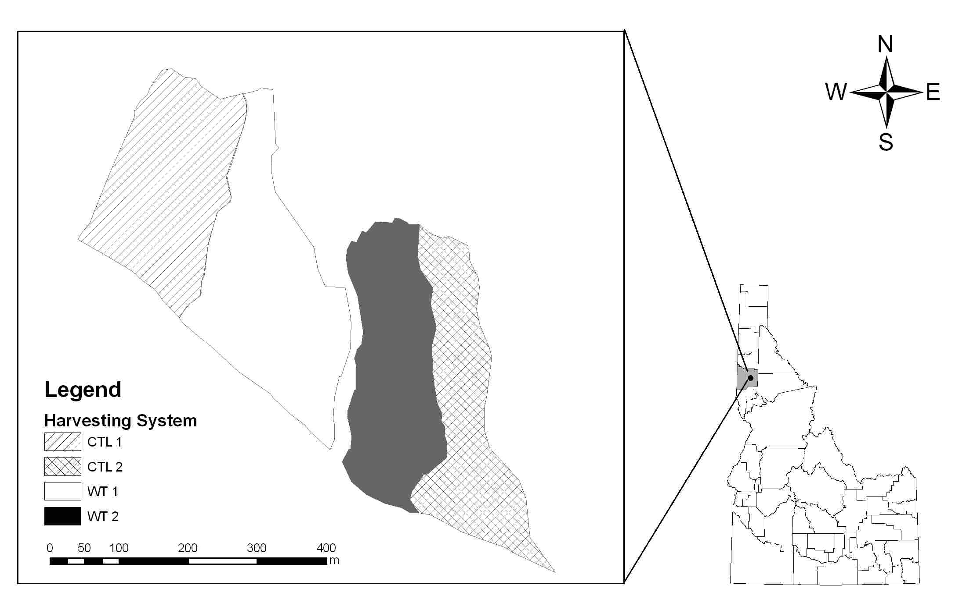
Figure 1. Location of the study site in northern Idaho
The harvest prescription for each stand was clearcutting using either CTL or WT harvest systems during May and June 2005. The CTL harvesting system used a harvester and a forwarder. The WT harvesting system used a feller-buncher, a track-based skidder, a processor, and a loader. A detailed description of each machine is provided in Table 1. Harvesting trails were delineated before harvesting to take advantage of topography. Only two of the old harvesting trails were effectively used for this operation; other old trails were not readily useable with the CTL and WT harvest systems.

Table 1. CTL and WT harvesting system equipment descriptions
Harvesting system | Machine | Description
CTL | Harvester | Valmet 500T  Cummins 6BTA, 171 HP engine  Hydraulic cab leveling system  Machine weight: 21,772 kg, track carrier
 | Forwarder | Valmet 890 with squirt boom loader  Volvo TD610 AW 172 HP engine  Hydraulic cab leveling system  Load capacity 16,011 kg
WT | Feller-buncher | Timbco T435 Hydro Buncher  Cummins series 215 HP engine  Quadco fixed head model 22  Machine weight: 25,950 kg, track carrier
 | Crawler | CAT D-518 skidder, 160 HP engine  Machine weight 12,576 kg, swing grapple
 | Processor | PC 220 Komatsu, 160 HP engine, track  carrier
 | Loader | PC 200 Komatsu, 140 HP engine, track  carrier

The number of machine passes were mapped over all trails during the harvest operation in each unit. Movements of the harvester and feller-buncher were not included in the number of machine passes since one pass of a tracked machine does not significantly impact this soil type (Han et al. 2006). A machine pass was defined as one round trip (one round trip = one trip empty + one trip loaded) regardless of whether the forwarder or the skidder was fully or partially loaded with wood. After harvesting, GPS data were collected with a Trimble Geo XT unit at every 15 m along the centerline of the trails to create a trail map. The width of each trail was measured every 15 m to determine the average width of the trail. In the CTL unit, width of the trail center and the wheel track were also measured since the forwarder tended to repeatedly travel the same track, but the skidder tracks were more diffuse and not easily delineated. The GPS and trail width data were used to calculate trail area used for primary wood transport in each harvest unit. A trail map by machine pass category was created using ArcGis 9.1 (ESRI, Inc. 1999; Fig. 2).

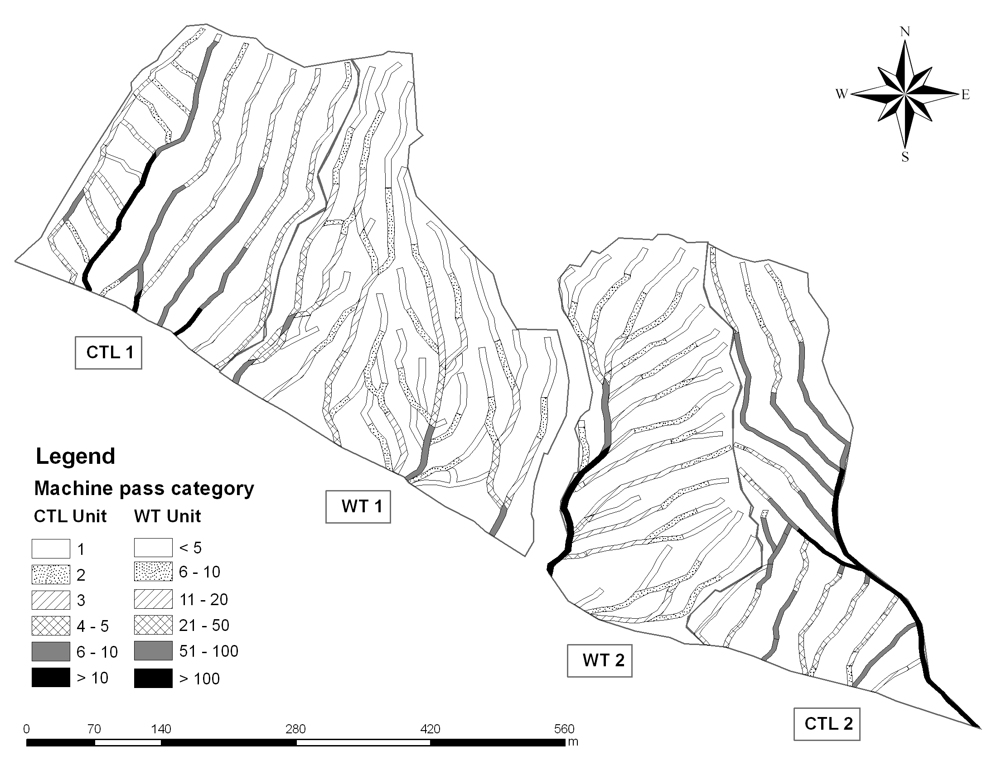
Figure 2. Map of the study site and the trails used by CTL and WT systems
A Rimik CP40 recording cone penetrometer (Agridry, Toowoomba, Australia) with a base cone area of 113 mm² was used to measure SRP. Readings in kilopascals (kPa) were automatically recorded in 25 mm increments as the penetrometer was manually inserted to a depth of 300 mm. To collect SRP data after harvesting, we installed transects across the center on all skid-trails at every 30 m (Fig. 3). On each transect, we collected SRP at the trail center (A), in both tracks (B), and in reference sampling points (C; off-trail area), respectively (Fig. 3). Three replicates of SRP were taken at each point.

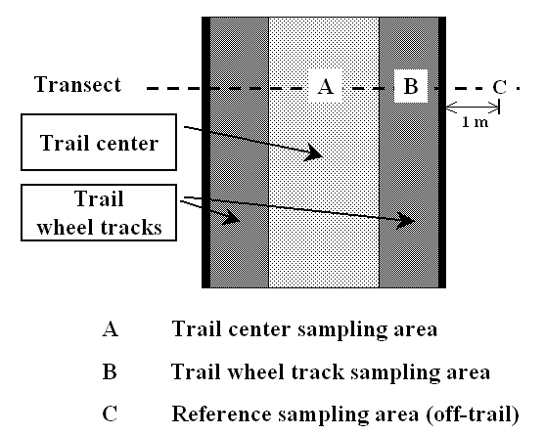
Figure 3. Diagram showing transect and sampling areas along the trail

Bulk density samples were collected along the same transects as SRP, but were located at every 90 m across the centerline. On each transect, BD samples were collected at the center (A), from one of the tracks (left or right) (B), and from the reference area (C; off-trail area) (Fig. 3). A core sampler (147 cm³) was used to collect BD samples at depths of 7.5 cm, 15 cm, and 22.5 cm. Soil cores were placed in plastic bags for transport from the field. In the laboratory, soil samples were weighed, oven-dried at 105 ºC for 24 hrs and reweighed. Net wet and dry weights were recorded to nearest 0.01g. BD was calculated with the gross soil dry weight and volume of the tube. Soil moisture contents were calculated from each BD sample and additional soil cores were taken before harvest to monitor soil moisture.
Logging slash was also surveyed along the same transects as the BD samples and SRP data. Slash was classified into three different levels (Bare: no slash, Light: 7.3 kg/m², and Heavy: 40.0 kg/m²). Slash weight was calculated using the downed woody debris survey method outlined by Brown (1974).
Data analysis was preformed using Statistical Analysis System (SAS) (SAS Institute Inc. 2001) and Statistical Package for the Social Sciences (SPSS) (SPSS Inc. 1998). Data were evaluated for normality before running the analyses. The Wilcoxon rank-sum test was used to compare the degree of soil compaction between the two different harvesting systems. The Kruskal-Wallis and multiple comparison tests were performed to test for differences among the three sampling regions (track, center, and reference). These tests were performed separately for each harvesting system (CTL and WT) and at each soil depth (7.5 cm, 15 cm, and 22.5 cm). The effect of slash was tested using a one-way analysis of variance (ANOVA), and regression analysis was used to develop the models that estimate the percent increase of SRP or BD. The significance level was set to 5% (α = 0.05).

RESULTS

Soil moisture

Average soil moisture in these study sites was highest in the upper soil layers and decreased with soil depth in all units (Fig. 4). Soil moisture was relatively constant (25 - 30% at 7.5 cm soil depth) throughout harvest operations and data collection. There was intermittent light rain for 4 days during the harvesting operation, but it did not cause significant changes in soil moisture at any soil depth (p<0.05).

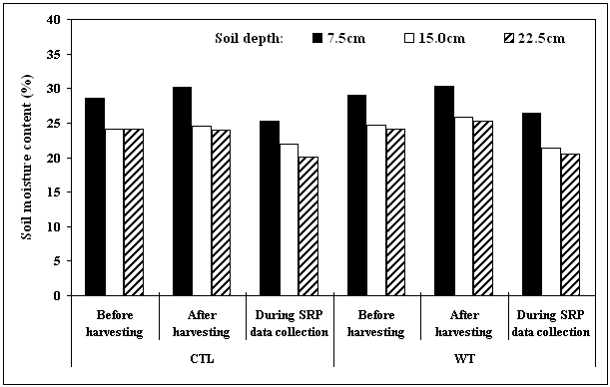
Figure 4. Average soil moisture content at three soil depths before and after harvest using CTL or WT systems as well as during the collection of soil resistance to penetration (SRP) data.

Soil resistance to penetration (SRP)

Pre-harvest measurements indicated that SRP readings increased with increasing soil depth in both CTL and WT harvesting units (Table 2). Both CTL and WT units had similar SRP readings at all soil depths, but SRP readings at 7.5 cm depth were significantly different (p<0.05). At this depth, SRP in the WT unit was significantly higher than that in the CTL unit (p<0.05). The percent increase of SRP resulted from harvesting activities was used to compare SRP readings between CTL and WT harvesting due to this initial difference between the CTL and WT unit at 7.5 cm soil depth.

Table 2. Mean of soil resistance to penetration (SRP) on the reference, trail center, and track after CTL or WT harvesting.
Location | Soil  depth  (cm) | CTL |  |  |  | WT |  |  | p-value
Location | Soil  depth  (cm) | n | Mean | SD¹ |  | n | Mean | SD¹ | p-value
Location | Soil  depth  (cm) | n | - - (kPa) - - |  |  | n | - - (kPa) - - |  | p-value
Reference | 7.5 | 425 | 974 | 453 |  | 537 | 1104 | 360 | < 0.001
Reference | 15.0 | 428 | 1314 | 608 |  | 537 | 1303 | 450 | 0.780
Reference | 22.5 | 426 | 1450 | 715 |  | 537 | 1412 | 551 | 0.381
Center | 7.5 | 427 | 1064 | 579 |  | 540 | 1336 | 653 | < 0.001
Center | 15.0 | 428 | 1421 | 692 |  | 539 | 1677 | 645 | < 0.001
Center | 22.5 | 426 | 1648 | 864 |  | 540 | 1771 | 743 | 0.022
Track | 7.5 | 851² | 2007 | 631 |  | 1077² | 1851 | 650 | < 0.001
Track | 15.0 | 851² | 2414 | 751 |  | 1074² | 2237 | 732 | < 0.001
Track | 22.5 | 852² | 2536 | 790 |  | 1073² | 2304 | 779 | < 0.001
¹ Standard deviation
² SRP data were collected in both tracks.

After harvesting, a SRP increase was noted in the center and track of the trails in both harvesting units (Table 2 and Fig. 5). In the center of the trail, higher SRP readings were generally found at all soil depths in the WT unit compared to the CTL trail center. Particularly, the percent increase of SRP at 15 and 22.5 cm soil depth was significantly higher in the WT unit than in the CTL unit (p<0.05; Fig. 5). However, greater percent increases of SRP in the tracks of the trails were found in the CTL than those in the WT unit (p<0.05). In the wheel track, the CTL unit had a SRP increase of 105 -147% while it was 82 - 88% in the WT unit. For all soil depths, the SRP readings were significantly higher than the reference SRP only in the track in the CTL units, but WT harvesting resulted in a significant increase of SRP in both the center and track areas as compared to the reference area (p<0.05; Table 3).

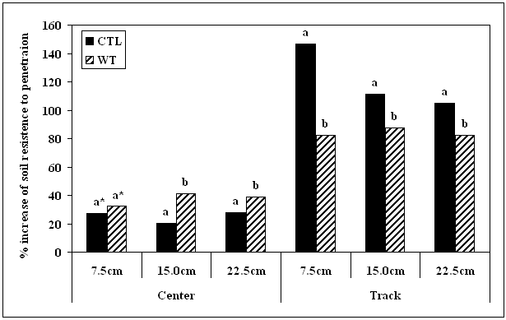
* Means with the same letter are not significantly different (p>0.05)
Figure 5. Percent increase of soil resistance to penetration (SRP) after harvesting using CTL or WT systems

Table 3. Mean values for soil resistance to penetration (SRP) collected from the reference, trail center, and track after harvesting using CTL or WT systems.
Harvesting  system | Soil  depth  (cm) | Location |  |  | p-value
Harvesting  system | Soil  depth  (cm) | Reference | Center | Track | p-value
Harvesting  system | Soil  depth  (cm) | - - - - - - - - - - (kPa) - - - - - - - - - - |  |  | p-value
CTL | 7.5 | 974 a* | 1064 a* | 2007 b* | < 0.001
CTL | 15.0 | 1314 a | 1421 a | 2414 b | < 0.001
CTL | 22.5 | 1450 a | 1648 a | 2536 b | < 0.001
WT | 7.5 | 1104 a | 1336 b | 1851 c | < 0.001
WT | 15.0 | 1303 a | 1677 b | 2237 c | < 0.001
WT | 22.5 | 1412 a | 1771 b | 2304 c | < 0.001
* Means in the same row with the same letter are not significantly different (p>0.05)
Soil bulk density (BD)

Average BD after CTL and WT harvesting for the trail center, the wheel track, and reference area are summarized in Table 4. Pre-harvest BD in both CTL and WT harvesting units was similar (p>0.05). BD readings in both the trail center and the wheel track were slightly higher in the WT unit than the CTL unit, but the difference was not significant (p>0.05). It was also noted that BD increased with increases in soil depth in both CTL and WT harvesting units.

Table 4. Bulk density (BD) in the reference, trail center, and track at three soil depths after harvesting with CTL or WT systems.
Location | Soil  depth  (cm) | CTL |  |  |  | WT |  |  | p-value
Location | Soil  depth  (cm) | n | Mean | SD* |  | n | Mean | SD* | p-value
Location | Soil  depth  (cm) | n | - - (g/cm³) - - |  |  | n | - - (g/cm³) - - |  | p-value
Reference | 7.5 | 47 | 0.88 | 0.13 |  | 59 | 0.88 | 0.12 | 0.933
Reference | 15.0 | 47 | 1.10 | 0.18 |  | 59 | 1.12 | 0.16 | 0.694
Reference | 22.5 | 47 | 1.22 | 0.22 |  | 59 | 1.19 | 0.16 | 0.402
Center | 7.5 | 47 | 0.97 | 0.17 |  | 59 | 1.02 | 0.18 | 0.112
Center | 15.0 | 47 | 1.18 | 0.19 |  | 59 | 1.24 | 0.17 | 0.115
Center | 22.5 | 47 | 1.27 | 0.21 |  | 59 | 1.29 | 0.17 | 0.511
Track | 7.5 | 47 | 1.11 | 0.16 |  | 59 | 1.19 | 0.17 | 0.016
Track | 15.0 | 47 | 1.27 | 0.18 |  | 59 | 1.30 | 0.17 | 0.411
Track | 22.5 | 47 | 1.35 | 0.20 |  | 59 | 1.37 | 0.20 | 0.649
* Standard deviation

After harvesting, both the CTL and WT harvest systems caused an increase of BD, but a greater increase in BD was observed in the WT unit in both the center and track of the trail (Table 4 and Fig. 6). The largest increase in BD was observed at the first depth class (7.5 cm) in both harvesting units. In the trail center, the percent increase of BD in the WT unit was significantly higher than that in the CTL unit at all soil depths (p<0.05). In the wheel track, BD at the 7.5 cm depth increased by 27% in the CTL unit and 36% in the WT unit (Fig. 6). The differences were significant at 7.5 cm and 22.5 cm (p<0.05), but not at 15 cm (p>0.05).
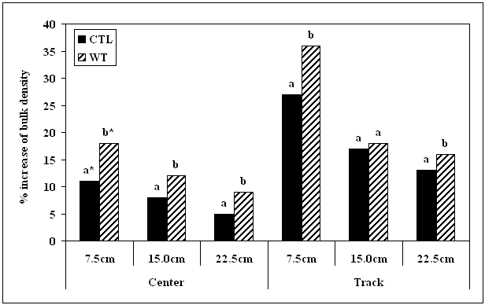* Means with the same letter are not significantly different (p>0.05)
Figure 6. Percent increase of soil bulk density (BD) after harvesting using CTL or WT systems

Table 5. Mean values for soil bulk density (BD) collected from the reference, trail center, and track after harvesting with CTL or WT systems.
Harvesting  system | Soil  depth  (cm) | Location |  |  | p-value
Harvesting  system | Soil  depth  (cm) | Reference | Center | Track | p-value
Harvesting  system | Soil  depth  (cm) | - - - - - - - - - - (g/cm³) - - - - - - - - - - |  |  | p-value
CTL | 7.5 | 0.88 a* | 0.97 b* | 1.11 c* | < 0.0001
CTL | 15.0 | 1.10 a | 1.18 a | 1.27 b | 0.0004
CTL | 22.5 | 1.22 a | 1.27 ab | 1.35 b | 0.0177
WT | 7.5 | 0.88 a | 1.02 b | 1.19 c | < 0.0001
WT | 15.0 | 1.12 a | 1.24 b | 1.30 b | < 0.0001
WT | 22.5 | 1.19 a | 1.29 b | 1.37 b | < 0.0001
* Means in the same row with the same letter are not significantly different (p>0.05)

When comparing the differences in mean values for BD, WT harvesting resulted in significantly higher bulk densities in both the center and the track of the skid trails, compared to the reference area at all soil depths (p<0.05; Table 5). In the CTL harvesting unit, BD in the wheel track (all depths) and the trail center at 7.5 cm were significantly different from the corresponding depths in the reference.
Trail area categorized by the number of machine passes

The GIS analysis allowed us to determine the percentage of trail area that was trafficked by the skidder in the WT harvest units and the forwarder in the CTL harvest units (Fig. 2). Average trail width in the WT units (4.55 m) was wider than that in the CTL units (3.62 m) (Table 6). In the CTL units, track width was discernable and measurable since the forwarder repeatedly traversed the same area in the trail and did not cross the center track. It was difficult to delineate the track area from the rest of the skid trail area in the WT harvesting units because when the trees were skidded the previous track was erased. The average width of the center area between tracks in the forwarding trails was 1.83 m. CTL harvesting used less area for primary wood transport (20% of total harvest unit) than WT harvesting (25% of total harvest unit). The highest percentage of machine passes in the CTL units fell in the 4 to 5 pass category (32%) while the “less than 5” pass category was highest (34%) in the WT unit. The combined 0 to 20 pass categories accounted for about 85% of the total trail area in the WT unit. In the CTL unit, the combined 3 to 10 pass categories accounted for 75% of the total trail area (Fig. 2, App. 1 and 2).

Table 6. Average trail width, track width, and area of trails in CTL and WT harvest units
Harvesting  system | Harvesting  unit  (ha) | Trail width |  |  | Track width | Trail length  (m/ha) | Trail area  in harvesting unit
Harvesting  system | Harvesting  unit  (ha) | n | Mean  (m) |  | Mean  (m) | Trail length  (m/ha) | ha | %
CTL | 8.9 | 153 | 3.62 |  | 1.79 | 549 | 1.77 | 20
WT | 10.6 | 199 | 4.55 |  | - * | 558 | 2.68 | 25
* The track width of the skid trails in the WT units was not distinguishable since trees being skidded erased any previous tracks.

Slash in the CTL harvesting unit

Slash covered 69% of the forwarding trail area in the CTL harvesting unit with 37% of the trail covered by heavy slash and 32% of the trail covered by light slash. In the track of the CTL forwarding trails, heavy slash mitigated the impacts of ground traffic by 89% at 7.5 cm and 53% at 15 cm as compared to SRP readings in bare ground that had no slash during harvesting (Fig. 7). Light amount of slash seemed to be effective in minimizing soil surface impacts from harvesting activities, but was not sufficient to significantly affect SRP readings (p>0.05). No significant effect of slash on SRP readings was shown in the center of forwarding trail (p>0.05). Soil BD was unaffected by slash in the track and center of the forwarding trails at any soil depth (p>0.05; Fig. 8). However, there was an indication that both heavy and light slash helped reduce the machine-caused ground pressures at 7.5 cm soil depth in the track of forwarding trails for soil BD.

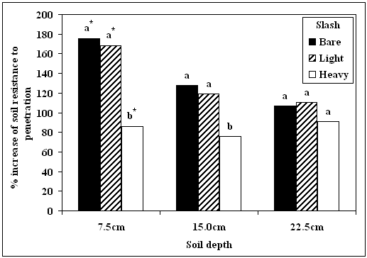
* Means with the same letter are not significantly different (p>0.05)
Figure 7. Percent increase of soil resistance to penetration (SRP) in the track with
different levels of slash in the CTL harvesting units
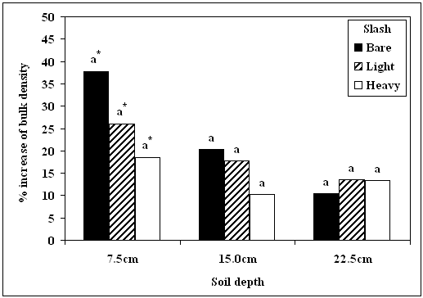
* Means with the same letter are not significantly different (p>0.05)
Figure 8. Percent increase of soil bulk density (BD) in the track with different
levels of slash in the CTL harvesting units
Prediction models to estimate potential soil impacts

For both harvesting systems, prediction models were developed to estimate percent increase of SRP and BD based on the number of machine passes, distance from landing area, initial SRP or BD, and slash amount (Tables 7 and 8).

Table 7. Prediction model to estimate percent increase of soil resistance to penetration when soil moisture content was 25 - 30%
Harvesting system | Soil depth  (cm) | Prediction model | r² | n
CTL | 7.5 | % increase = 1819.74 + 32.64ln(M¹) – 20.23ln(D¹) – 233.16ln(I¹)  (0.0267)² (0.0138) (<0.0001)  – 84.62(S1¹) – 43.35(S2¹)  (0.0003) (0.0269) | 0.59 | 144
CTL | 15 | % increase = 1221.59 + 46.38ln(M) – 16.30ln(D) – 151.04ln(I) –  (<0.0001) (0.0014) (<0.0001)  55.03(S1) – 34.56(S2)  (<0.0001) (0.0036) | 0.65 | 144
CTL | 22.5 | % increase = 1260.51 + 50.83ln(M) – 20.96ln(D) – 155.62ln(I) –  (<0.0001) (<0.0001) (<0.0001)  25.97(S1) – 17.98(S2)  (0.0550) (0.1165) | 0.67 | 144
WT | 7.5 | % increase = 1156.59 + 13.19ln(M) – 17.69ln(D) – 145.92ln(I)  (0.0007) (0.0020) (<0.0001) | 0.53 | 180
WT | 15 | % increase = 1272.28 + 23.01ln(M) – 16.41ln(D) – 161.66ln(I)  (<0.0001) (0.0078) (<0.0001) | 0.53 | 180
WT | 22.5 | % increase = 1213.78+ 19.64ln(M) – 20.85ln(D) – 148.86ln(I)  (<0.0001) (0.0007) (<0.0001) | 0.54 | 180
¹ M: the number of machine passes, D: the distance (m) from landing area, S1: heavy slash = 1 and others (light slash or bare ground) = 0, S2: light slash = 1 and others (heavy slash or bare ground) = 0, and I: initial values for soil resistance to penetration.
² Values in ( ) indicate a p-value for testing the significance of each variable that contributes to potential increase of soil resistance to penetration.

In both harvesting systems, the percent increase of SRP and BD increased with an increase in the number of machine passes. However, the distance from landing area, and initial SRP should a negative relationship with the percent increase of SRP meaning the percent change was less pronounced as distance from the landing increased. For all soil depths, the number of machine passes and initial values of SRP were effective (p<0.05) in predicting percent changes in SRP from CTL and WT harvesting, but those effects were not significant in predicting percent changes in BD. Slash in the CTL harvesting unit was effective (p<0.05) in predicting percent change of SRP, but it was marginal (p = 0.500 – 0.1195) for BD. The models for SRP (r² = 0.53 to 0.67) provided better fits to the data than that for BD (r² = 0.36 to 0.55).

Table 8. Prediction model to estimate % increase of soil bulk density (BD) when soil moisture was 25 - 30%
Harvesting system | Soil depth  (cm) | Prediction model | r² | n
CTL | 7.5 | % increase = 68.28 + 0.11ln(M¹) – 9.35ln(D¹) – 104.63ln(I¹) –  (0.9832)² (0.0034) (<0.0001)  13.63(S1¹) – 12.62(S2¹)  (0.0593) (0.0501) | 0.55 | 47
CTL | 15 | % increase = 32.67 + 3.63ln(M) – 2.78ln(D) – 51.93ln(I) –  (0.3663) (0.2404) (0.0001)  8.49(S1) – 3.02ln(S2)  (0.1195) (0.5285) | 0.37 | 47
CTL | 22.5 | % increase = 51.81 + 2.41ln(M) – 5.20ln(D) – 66.50ln(I) –  (0.6011) (0.0642) (<0.0001)  3.64(S1) – 2.66(S2)  (0.5573) (0.6309) | 0.40 | 47
WT | 7.5 | % increase = 16.24 + 5.72ln(M) – 1.14ln(D) – 106.50ln(I)  (0.0218) (0.7828) (<0.0001) | 0.47 | 59
WT | 15 | % increase = 49.35 + 3.57ln(M) – 6.82ln(D) – 47.96ln(I)  (0.0109) (0.0043) (<0.0001) | 0.49 | 59
WT | 22.5 | % increase = 52.91 +3.73ln(M) – 7.61ln(D) – 41.65ln(I)  (0.0251) (0.0081) (0.0008) | 0.36 | 59
¹ M: the number of machine passes, D: the distance (m) from landing area, S1: heavy slash = 1 and others (light slash or bare ground) = 0, S2: light slash = 1 and others (heavy slash or bare ground) = 0, and I: initial values for soil bulk density.
² Values in ( ) indicate a p-value for testing its significance of each variable that contributes to potential increase of soil bulk density.
DISCUSSION

Degree of soil compaction in the trails

Soil resistance to penetration (SRP)
After harvesting with soil moisture levels around 25 – 30%, both CTL and WT systems resulted in substantial increases in SRP in the track of trails at all soil depths compared to the reference area. We found that CTL harvesting caused little increase in SRP in the trail center, but had greater increases in SRP in the track compared to those found in the WT harvesting unit. The forwarder in the CTL harvesting remained in the wheel tracks created during previous trips and did not drive on the center of the trails. Han et al. (2006) found similar results on other fine textured soils in the Inland Northwest, USA, where CTL harvest did not create significant soil compaction in the center of the trail compared to the reference areas. However, the skidder in WT harvesting system did not use the same tracks and caused a high degree of soil disturbance within the skid trail. Allbrook (1986) also found that WT harvesting on a sandy loam soil at high soil moisture contents caused a significant increase of SRP in the center of the trails.
In the wheel track, both harvesting systems showed a significant increase in SRP over the center and reference areas at all soil depths. Past studies reported the percent change of SRP from the various soil conditions using CTL and WT harvesting. Han et al. (2006) reported that in fine-loamy soils SRP readings increased up to 260% in the track after harvesting using a CTL harvesting system with 21 – 30% soil moisture. Allbrook (1986) found on a sandy loam soil that WT harvesting resulted in 157% increase in the track with soil moisture at 38%. Williamson and Neilsen (2000) reported that SRP after harvesting in a WT unit increased by 167% under wet conditions on a sandy loam soil. Compared to past studies, this study found a smaller increase of SRP. While this study was performed on a silt loam soil, past studies were mostly conducted on sandy loam soils with soil moisture conditions comparable to this study.
Soil bulk density (BD)
Both the CTL and WT units showed an increase of soil BD in both the center and track of the trail at all soil depths after harvest. Percent change in BD is often used as an index of change in soil productivity (Froehlich and McNabb 1984). While there was no significant difference in BD between the center of the trail and the undisturbed area at any soil depth in the CTL unit, BD in the WT unit was 18% higher in the center of the trail compared to the undisturbed areas.
In the track of the trail, both the CTL and WT systems caused a high percent increase of BD at all soil depths. The percent increase of BD in this study was comparable to those reported by Williamson and Neilsen (2000). They reported that in a WT harvesting unit BD was increased by 40% in wet soil conditions. However, other past studies observed a slightly lower percent increase in BD than this study (McNeel and Ballard 1992; Allbrook 1986; Lanford and Stokes 1995). These differences may be caused by a combined effect of soil moisture, soil texture, harvesting systems and initial soil properties (i.e. initial BD) (Froese 2004).

Soil resistance to penetration (SRP) and soil bulk density (BD)
For this study, SRP and BD were measured to estimate the degree of soil compaction in each harvesting units. Although both harvesting units had similar soil texture and moisture condition, results from SRP readings in the wheel track were not consistent with those from BD. While higher SRP readings were generally found at all soil depths in the CTL units, BD in the WT units was significantly higher than those from the CTL unit. The different results between the two methods possibly originated from high field variability of soils in the harvesting units as indicated by the large standard deviations (Table 2 and 4). Soil physical properties measured by SRP and BD may vary significantly between two neighboring points in the same area without an apparent cause. This field variability can be important in large areas. Silva et al. (1989) suggested that field analyses of soil data are difficult because of spatial variability and heterogeneity resulting from several soil formation factors. For example, organic matter content and its distribution in a soil would affect its physical properties including its compactability (Zhang et al. 1997).
The relationship between SRP and BD has been compared in a few soils. Allbrook (1986) and Clayton (1990) reported that SRP was related positively to BD. They also found that compacted soils showed high increases in SRP, yet only small increases in BD. However, Froese (2004) found that the BD and SRP did not have a strong correlation. In our study, BD was also not strongly correlated with SRP (r² = 0.30) (App. 5). Soil moisture, soil texture, organic matter content, rock fragments, and field variability are factors often affecting the correlations (Froese 2004). Vasquez et al. (1991) also suggested that high correlations between SRP and BD were limited to homogeneous soils under controlled conditions.

Extent of soil compaction

Knowledge of the extent of significant damage to the soil is important in assessing effects of harvesting systems (Bettinger et al. 1994). The extent of trail area usually varies with terrain, tree size and volume, harvesting methods, moisture conditions at harvesting, equipment, and harvesting systems (Landsberg et al. 2003; Miller et al. 2004). In this study, only the trail areas used for primary wood transport were measured and GIS analysis was used to quantify the extent of soil compaction.
Although the two different harvesting units had similar terrain, tree density, harvesting method, and moisture conditions at harvesting, CTL harvesting created less trail area for primary wood transport than did the WT harvesting system. The primary difference in trail area between the two harvesting systems originated from the width of trails (Table 6). The forwarder in the CTL harvesting was able to use the same track on subsequent trips, while the skidder in the WT harvesting tended to widen the trail because evidence of the previous track had been erased by the trees being skidded. The length of trail was not significantly different between CTL (549 m/ha) and WT (558 m/ha) harvesting. Similar outcomes were found in past studies (Gingras 1994; Lanford and Stokes 1995; Stewart et al. 1988; McNeel and Ballard 1992)
When past studies evaluated compacted areas at a CTL harvesting site, they generally included the entire trail, not distinguishing between the center and the track of the trail (Gingras 1994; Lanford and Stokes 1995; McNeel and Ballard 1992). However, this study found that the center of the trail and undisturbed area were not significantly different in terms of SRP (Table 4). Therefore, when the compacted area was estimated in this CTL harvesting unit, only the track area of the trail was considered as compacted. The compacted area in the CTL units occupied 10 percent of the harvesting area in this study. Although the center of the track area was not significantly impacted and, therefore, not included in our estimates of track distribution, there still may be impacts on overall soil productivity as trees growing in the track are likely to intersect the compacted track with more frequency than trees growing in the reference area.
The GIS analysis allowed us to determine the percentage of trail area by the number of machine pass categories (Fig. 2). The collection of machine pass data is difficult, but provides a visual representation of heavily trafficked areas and the severity of soil compaction. It also provides a database representing historic use of the site for managers (Bettinger et al. 1994). This information may be used to select harvesting systems and trails in future logging operations, and can also assist in establishing plans for tree regeneration in the harvested area.

Importance of slash to mitigate compaction

Several past studies reported that CTL harvesting was a very effective way to minimize soil compaction due to the slash mat created during processing (McDonald and Seixas 1997; McMahon and Evanson 1994; Han et al. 2006). However, the trail area that is not covered by slash may be severely impacted due to direct contact between the machine track and the soil surface. In this study, while operations on heavy slash (37% of the trail area) showed an increase of up to 86% in SRP and 19% in BD at 7.5 cm soil depth, 31% of the trail area on bare ground showed a 180% increase in SRP and a 38% increase in BD (Fig. 7 and 8).
The buffering effect of slash on mineral soil compaction was found in the heavy slash (40.0 kg/m²) applied to the track. A small amount of slash did not provide enough cushioning in wet soil to absorb the ground pressure and vibration of the harvesting equipment. Light slash tended to be crushed into pieces and could no longer distribute and absorb the impact of the machine. Han et al. (2006) reported similar results when a light slash mat (7.5 kg/m²) was left in a CTL harvesting on wet soil. Jakobsen and Moore (1981) reported that a critical amount of slash required to protect soil is 18 kg/m². However, the critical slash amount may change with varying soil textural classes and moisture conditions. Other studies have shown that the effectiveness of slash was an interaction of the amount of slash and the number of machine passes (McDonald and Seixas 1997; Han et al. 2006). Initially, the slash provides a good buffer, but with increasing machine passes, the slash breaks down and becomes less effective at minimizing soil impacts from machine traffic.

Prediction models to estimate potential soil impacts

The prediction model developed to estimate percent increases in soil compaction caused by CTL or WT harvesting includes the number of machine passes, distance from the landing area, initial SRP or soil BD and logging slash amounts. This information is useful when forest managers develop strategies to prevent unacceptable levels of soil damage that may degrade soil productivity. Our models indicate that the number of machine passes is highly correlated with increases in SRP in both CTL and WT harvesting systems. However, this was not the case for BD, in part, due to smaller number of BD samples. In the wheel track, most soil compaction occurred after a few passes of a laden logging machine, with 70% of soil compaction in the first 7.5 cm of soil achieved after only 5 machine passes in the CTL unit (Fig. 9). In the WT unit, 80% of soil compaction in the top 7.5 cm of soil occurred after only 10 machine passes (Fig. 9). Soil compaction continued with further passes in both harvesting units, but increase of soil compaction was lower. Similar results have been reported elsewhere. Rollerson (1990) reported that most soil compaction occurs after the first 10 to 20 passes in a WT unit. Williamson and Neilsen (2000) found that 62% of final soil compaction occurred after only one pass on skid trails. Han et al. (2006) found that there was a rapid increase in SRP up to the second pass of a fully loaded forwarder in a CTL unit.
The initial values of SRP and BD had highly negative correlations with their respective percent increases in the prediction models (Fig. 10). The percent increases were greater in soils with lower initial SRP and BD. Page-Dumroese et al. (2006) also reported that as initial BD increased, the level of change decreased. These results will be useful in determining the limitations on harvesting as a function of season. High initial SRP values and BD under dry season conditions may result in less soil compaction after operations (Page-Dumroese et al. 2006). Similar results were observed by Williamson and Neilson (2000), and Han et al. (2006). They also suggested that scheduling harvest operation for drier conditions could minimize impacts on soils.

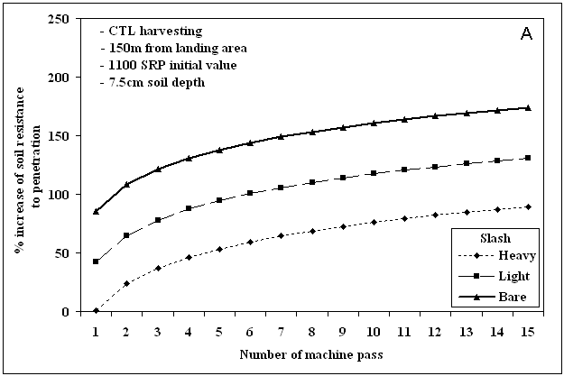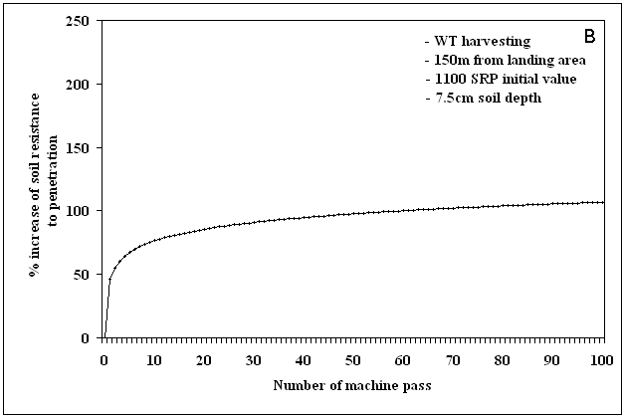
Figure 9. Percent increase in soil resistance to penetration (SRP) as a function of the
number of machine passes in CTL (A) and WT (B) harvesting
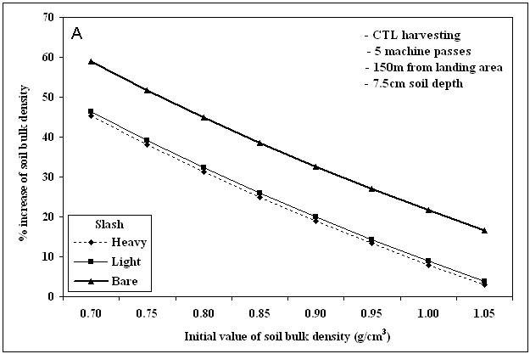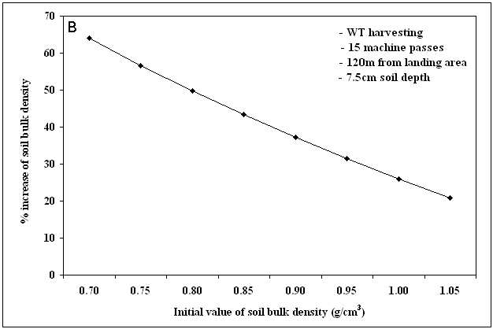
Figure 10. Percent increase in soil bulk density (BD) as a function of initial soil
bulk density (BD) in CTL (A) and WT (B) harvesting
The prediction models showed that the percent increases in SRP and BD were negatively correlated with the distance from the landing area (Fig. 11). Trails close to the landing area receive higher density machine traffic and result in greater compaction than areas farther from the landing area.

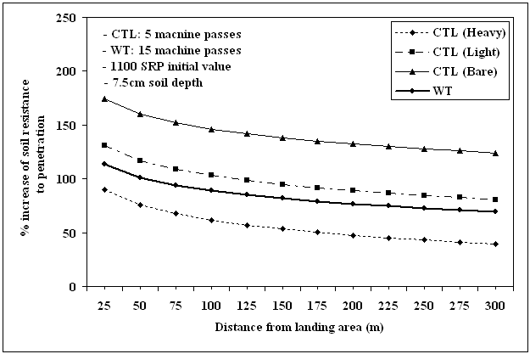

Figure 11. Percent increase in soil resistance to penetration (SRP) as a function of the

distance from the landing area in CTL and WT harvesting

CONCLUSION

Soil compaction is a common consequence of mechanized forest harvesting operations, especially when soil moisture is high (around 30%). This study was conducted to estimate the degree and extent of soil compaction between CTL and WT harvesting systems in northern Idaho. At high moisture levels, both CTL and WT harvestings caused a high degree of soil compaction in the track of the trails. CTL harvesting left less soil compaction in the trail center and used less area for primary wood transport compared to WT harvesting. Therefore, WT harvesting may require more careful planning and layout than CTL harvesting when forest managers design a harvesting plan using a ground-based harvesting system. Scheduling harvest operations to correspond with dry seasons can effectively minimize soil compaction in both harvesting systems. Slash in the CTL harvesting unit appeared to be effective in minimizing soil compaction, but only about 30% of the CTL forwarding trails were covered by heavy slash (40.0 kg/m²).
This study also supports the use of designated and old skid trails. High initial BD soils resulted in less change in soil compaction than low initial BD soils. Old skid trails typically have high initial BD. In addition, most soil compaction occurred after a few pass of a laden logging machine in this study. Therefore, traffic restriction to designated skid trails would be an effective strategy to minimize soil compaction on ash-cap soils or fine textured soils that have low initial BD. In this study, we also found that trails close to the landing area had higher soil densities than trails farther from the landing area. Therefore, when forest managers design harvesting operations, careful attention and additional preparations such as slash treatment could help limit soil compaction impacts on the areas close to log landings.

REFERENCES

Adams, P.W. 1990. Soil compaction in woodland properties: The woodland workbook. Oregon State Univ., Corvallis, OR. 7p.
Adams, P.W. and H.A. Froehlich. 1984. Compaction of forest soils, USDA For. Serv. Res. Pap. PNW-217. Pacific Northwest Res. Stn., Portland, OR. 13p.
Allbrook, R.F. 1986. Effect of skid trail compaction on a volcanic soil in central Oregon. Soil Sci. Soc. Am. J. 50:1344-1346.
Barker, R.J. 1981. Soil survey of Latah County area, Idaho. USDA Soil Con. Ser. 116p.
Bettinger, P., D. Armlovich, and L. D. Kellogg. 1994. Evaluating area in logging trails with a Geographic Information System. Am. Soc. Agri. Eng. 37(4):1327-1330.
Brown, J.K. 1974. Handbook for inventorying downed woody material. USDA Agric. Handb. Ogden, Utah: Intermountain forest and range experiment station. 24p.
Clayton, J.L. 1990. Soil disturbance resulting from skidding logs on granite soils in central Idaho. USDA For. Serv. Res. Pap. INT-436. 8p.
ESRI, Inc. 1999. ArcGIS 9.1. Redlands, CA.
Froehlich, H.A. and D.H. McNabb. 1984. Minimizing soil compaction in Pacific Northwest forests. P. 159-192 in E.L. Stone (ed.) Proc. Forest Soils and Treatment Impacts Conf. Univ. of Tennessee, Knoxville, TN.
Froehlich, H.A., J. Azevedo, P. Cafferata, and D. Lysne. 1980. Predicting soil compaction on forested land. USDA For. Serv. Fin. Rep. Equip. Dev. Centre, Missoula, MT, 120p.
Froese, Karl. 2004. Bulk density, soil strength, and soil disturbance impacts from a cut-to-length harvest operation in north central Idaho. M.Sc. thesis, Univ. of Idaho, Moscow, ID. 66p.
Gent, J.A. and R. Ballard. 1984. Impact of intensive forest management practices on the bulk density of lower Coastal Plain and Piedmont soils. South. J. App. For. 9:44-48.
Gingras, J.F. 1994. A comparison of full-tree versus cut-to-length systems in the Manitoba model forest. FERIC, Quebec, Canada. SR-92. 16p.
Han, H.-S. D. Dumroese, S.-K. Han, and J. Tirocke. 2006. Effect of slash, machine passes, and moisture content on soil strength in a cut-to-length harvesting. J. For. Eng. in press.
Hartsough, B.R., E.S. Drews, J.F. McNeel, T.A. Durston and B.J. Stokes. 1997. Comparison of mechanized systems for thinning ponderosa pine and mixed conifer stands. For. Prod. J. 47(11/12):59-68.
Jakobsen, B.F. and G.A. Moore. 1981. Effects of two types of skidders and of slash cover on soil compaction by logging of mountain ash. Aus. J. For. Res. 11: 247-255.
Landsberg, J.D., R.E. Miller, H.W. Anderson, and J.S. Tepp. 2003. Bulk density and soil resistance to penetration as affected by commercial thinning in north eastern Washington. USDA For. Serv. Res. Pap. PNW-RP-551. Pacific Northwest Res. Stn., Portland, OR. 35p.
Lanford, B.L. and B.J. Stokes. 1995. Compaction of two thinning systems: Part 1. Stand and site impacts. For. Pro. J. 45(5):74-79.
McDonald, T.P. and F. Seixas. 1997. Effect of slash on forwarder soil compaction. J. For. Eng. 8(2):15-26.
McMahon, S. and T. Evanson. 1994. The effect of slash cover in reducing soil compaction resulting from vehicle passage. LIRO, Rotorua, NZ. LIRO Report 19(1):1-8.
McNeel, J.F. and T.M. Ballard. 1992. Analysis of site stand impacts from thinning with a harvester-forwarder system. J. For. Eng. 4(1):23-29.
Miller, R.E., S.R. Colbert, and L.A. Morris. 2004. Effects of heavy equipment on physical properties of soils and on long-term productivity: A review of literature and current research. Tech. Bull. No. 887. National Council for Air and Stream Improvement (NCASI), Research Triangle Park, NC. 76p.
Page-Dumroese, D.S., M.F. Jurgensen, A.E. Tiarks, F. Ponder, F.G. Sanchez, R.L. Fleming, J.M. Kranabetter, R.F. Powers, D.M. Stone, J.D. Elioff, and D.A. Scott. 2006. Soil physical property changes at the North American long-term soil productivity study sites: 1 and 5 years after compaction. Can. J. For Res. 36: 551-564.
Ponsse. 2005. Mechanical harvesting methods. p.14-17 in the PONSSE OYJ annual report. PONSSE OYJ. Finland.
Pritchett, W.L., and R.F. Fisher. 1987. Properties and Management of Forest Soils. 2nd ed. John Wiley and Sons, NY. 494p.
Quesnel, H. and M. Curran. 2000. Shelterwood harvesting in root disease infected forests in southeastern British Columbia: post-harvest soil compaction. EP-1186. Extension Note EN-048. Forest Sciences Section, Nelson Forest Region, BCMOF. Nelson, BC.
Rollerson, T.P. 1990. Influence of wide-tire skidder operations on soils. J. For. Eng. 2:23–30.
SAS Institute. 2001. SAS for Windows, Version 8.2. SAS Inst., Cary, NC.
Silva, A.P., P.L. Libardi, and S.R. Vieira. 1989. Variabilidade espacial da resistência à penetração de um latossolo vermelho-escuro ao longo de uma transeção. Rev. Bras. Ciên. Solo, 13:1-5.
Soane, B.D. 1986. Processes of soil compaction under vehicular traffic and means of alleviating it. p. 265-283 in Land clearing and development in the tropics. R. Lal et al. (eds.). Balkema Publ., Rotterdam, Boston.
SPSS. 1998. SPSS for Windows, Version 9.0.0. SPSS Inc., Chicago, IL.
Steinbrenner, E.C. and S.P. Gessel. 1955. The effect of tractor logging on physical properties of some forest soils in southwestern Washington. Soil Sci. Soc. Am. Proc. 19(3):372-376.
Stewart, R., H. Froehlich, and E. Olsen. 1988. Soil compaction: An economic model. West. J. Appl. For. 3(1):20-22.
USDA. 1996. Soil quality resource concerns: Compaction. USDA Nat. Res. Con. Ser. 2p.
Vasquez, L., D.L. Myhre, E.A. Hanlon, and R.N. Gallaher. 1991. Soil penetrometer resistance and bulk density relationships after long-term no tillage. Commun. Soil Sci. Plan. Anal. 22:2101-2117.
Williamson, J.R. and W.A. Neilsen. 2000. The influence of forest site on rate and extent of soil compaction and profile disturbance of skid trails during ground-based harvesting. Can. J. For. Res. 30:1196-1205.
Wronski, E.B. 1980. Logging trials near Tumut. Logger, April / May:10-14.
Zhang, H., K.H. Hartge, and H. Ringe. 1997. Effectiveness of organic matter incorporation in reducing soil compactibility. Soil Sci. Soc. Am. J. 61:239-245.
APPENDIX

Appendix 1. The percentage of skid-trail area by machine categories in CTL unit
Machine Pass  Categories | CTL 1 |  |  | CTL 2
Machine Pass  Categories | Area in skid trail |  | % trails in each  machine  pass category | Area in skid trail |  | % trails in each  machine  pass category
Machine Pass  Categories | ha | % | % trails in each  machine  pass category | ha | % | % trails in each  machine  pass category
1 | 0.03 | 0.61 | 3.16 | 0.02 | 0.50 | 2.47
2 | 0.10 | 2.05 | 10.53 | 0.05 | 1.25 | 6.17
3 | 0.22 | 4.51 | 23.16 | 0.08 | 2.00 | 9.88
4-5 | 0.32 | 6.56 | 33.68 | 0.24 | 6.00 | 29.63
6-10 | 0.20 | 4.10 | 21.05 | 0.29 | 7.25 | 35.80
> 10 | 0.08 | 1.64 | 8.42 | 0.13 | 3.25 | 16.05
Total | 0.95 | 19.47 | 100.00 | 0.81 | 20.25 | 100.00

Appendix 2. The percentage of skid-trail area by machine categories in WT unit
Machine Pass  Categories | WT 1 |  |  | WT 2
Machine Pass  Categories | Area in skid trail |  | % trails in each  machine  pass category | Area in skid trail |  | % trails in each  machine  pass category
Machine Pass  Categories | ha | % | % trails in each  machine  pass category | ha | % | % trails in each  machine  pass category
< 5 | 0.59 | 9.82 | 37.34 | 0.35 | 7.69 | 31.53
6 – 10 | 0.43 | 7.15 | 27.22 | 0.36 | 7.91 | 32.43
11 – 20 | 0.30 | 4.99 | 18.99 | 0.25 | 5.49 | 22.52
21 – 50 | 0.20 | 3.33 | 12.66 | 0.05 | 1.10 | 4.51
51 – 100 | 0.06 | 0.99 | 3.79 | 0.03 | 0.66 | 2.70
> 100 | - | - | - | 0.07 | 1.54 | 6.31
Total | 1.58 | 26.28 | 100.00 | 1.11 | 24.39 | 100.00
Appendix 3. Prediction model to estimate percent increase of soil resistance to penetration (Soil moisture content was 25 - 30%)
Harvesting system | Soil depth  (in.) | Prediction model | r²
CTL | 3 | % increase = 1844.06 + 32.60ln(M¹) – 20.26ln(D¹) – 233.16ln(I¹)  (0.0268)² (0.0137) (<0.0001)  – 84.58(S1¹) – 42.37(S2¹)  (0.0003) (0.0268) | 0.59
CTL | 6 | % increase = 1240.70 + 46.37ln(M) – 16.26ln(D) – 151.03ln(I) –  (<0.0001) (0.0014) (<0.0001)  55.00(S1) – 34.56(S2)  (<0.0001) (0.0036) | 0.65
CTL | 9 | % increase = 1284.78 + 50.82ln(M) – 20.90ln(D) – 155.58ln(I) –  (<0.0001) (<0.0001) (<0.0001)  25.92(S1) – 17.98(S2)  (0.0555) (0.1167) | 0.67
WT | 3 | % increase = 1177.87 + 13.23ln(M) – 17.58ln(D) – 146.06ln(I)  (0.0007) (0.0023) (<0.0001) | 0.53
WT | 6 | % increase = 1293.22 + 22.99ln(M) – 16.57ln(D) – 161.72ln(I)  (<0.0001) (0.0071) (<0.0001) | 0.53
WT | 9 | % increase = 1238.61 +19.67ln(M) – 20.78ln(D) – 148.93ln(I)  (<0.0001) (0.0008) (<0.0001) | 0.54
¹ M: the number of machine passes, D: the distance (ft) from landing area, S1: heavy slash = 1 and others = 0, S2: light slash = 1 and others = 0, and I: initial soil resistance to penetration.
² Values in ( ) indicate a p-value for testing its significance of each variable that contributes to potential increase of soil resistance to penetration.

Appendix 4. Prediction model to estimate % increase of soil bulk density (Soil moisture was 25 - 30%)
Harvesting system | Soil depth  (in.) | Prediction model | r²
CTL | 3 | % increase = 79.43 + 0.11ln(M¹) – 9.36ln(D¹) – 104.70ln(I¹) –  (0.9829)² (0.0034) (<0.0001)  13.63(S1¹) – 12.63(S2¹)  (0.0595) (0.0500) | 0.55
CTL | 6 | % increase = 36.01 + 3.63ln(M) – 2.79ln(D) – 51.92ln(I) –  (0.3663) (0.2402) (0.0001)  8.49(S1) – 3.02ln(S2)  (0.1195) (0.5279) | 0.37
CTL | 9 | % increase = 58.10 + 2.41ln(M) – 4.87ln(D) – 65.99ln(I) –  (0.6006) (0.0637) (<0.0001)  3.65(S1) – 2.65(S2)  (0.5568) (0.6325) | 0.40
WT | 3 | % increase = 17.69 + 5.72ln(M) – 1.16ln(D) – 106.50ln(I)  (0.0218) (0.7800) (<0.0001) | 0.47
WT | 6 | % increase = 57.78 + 3.57ln(M) – 6.95ln(D) – 47.95ln(I)  (0.0109) (0.0041) (<0.0001) | 0.49
WT | 9 | % increase = 62.08 +3.73ln(M) – 7.63ln(D) – 41.64ln(I)  (0.0250) (0.0079) (0.0008) | 0.36
¹ M: the number of machine passes, D: the distance (ft) from landing area, S1: heavy slash = 1 and others = 0, S2: light slash = 1 and others = 0, and I: initial soil bulk density.
² Values in ( ) indicate a p-value for testing its significance of each variable that contributes to potential increase of soil resistance to penetration.
Appendix 5. Relationship between soil resistance to penetration and bulk density
